**REPORT 2**

Digital Signal Processing

Teacher: prof. dr hab. Vasyl Martsenyuk

**Lab 2**

Date 18.10.2024

**Topic:** "Windowing"

**Variant 1**

Imię Nazwisko: Mariusz Jagosz

Informatyka II stopień,

niestacjonarne,

1 semestr,

Gr.A

**1. Generate three sine signals of given f1, f2, and f3 and amplitude |x[k]|max for the sampling frequency fs in the range of 0 ≤ k < N. Plot: 1 1. the "normalized" level of the DFT spectra. 2. the window DTFT spectra normalized to their mainlobe maximum. The intervals for f, Ω, and amplitudes should be chosen by yourself for the best interpretation purposes. Interpret the results of the figures obtained regarding the best and worst case for the different windows. Why do the results for the signals with frequencies f1 and f2 differ?**

**2. Input data:**

**No f1 f2 f3 |x[k]|max fs N**

**1 300 300.25 299.75 2 400 2000**

**3. Commands used (or GUI):**

1. The source code has been put into the repository under
2. Link to the repo: [unibb/Digital signal processing/Task1 at main · mariuszjagosz/unibb (github.com)](https://github.com/mariuszjagosz/unibb/tree/main/Digital%20signal%20processing/Task1)

**4. Outcomes:**

Plot:

Matrix K:

Matrix W:

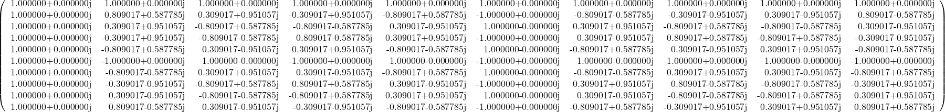

**5. Conclusions:**

In this report I’ve shown how I synthesized a discrete-time signal using the Inverse Discrete Fourier Transform (IDFT) in matrix notation for N = 10.

The W matrix was calculated according to the equation:

While the K matrix was calculated based on this outer product:

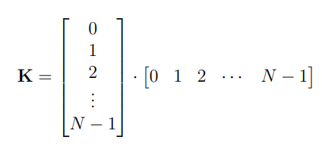

The synthesized signal ​ was computed and plotted, showcasing both its real and imaginary components. The IDFT implementation was validated using the function *np.allclose* to see if the signal matched the *ifft* function. Overall, this exercise demonstrated the effectiveness of using matrix operations for IDFT and highlighted the importance of visualization in analyzing discrete-time signals.